**Name: Jesnamol Thomas**

**Roll No: 6**

**Batch: B**

**Date: 12/05/22**

**NETWORKING & SYSTEM ADMINISTRATION LAB**

**Experiment No.: 10**

**Aim**

Sum of all digits of a number.

**Procedure**

#!/bin/bash

echo "Enter the digit"

read num

sum=0

while [ $num -gt 0 ]

do

mod=`expr $num % 10`

sum=`expr $sum + $mod`

num=`expr $num / 10`

done

echo $sum

**Output**

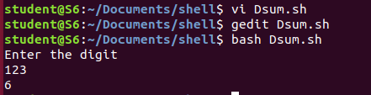

**Aim**

Find average of n numbers using loop.

**Procedure**

#!/bin/bash

echo "Enter the limit"

read n

i=1

sum=0

echo "Enter the numbers"

while [ $i -le $n ]

do

read num

sum=$((sum + num))

i=$((i + 1))

done

avg=$(echo $sum / $n | bc -l)

echo "the average is:"$avg

**output**

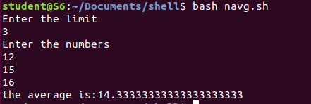

**Aim**

Arithmetic operations using switch cases.

**Procedure**

#!/bin/bash

echo "Enter Two numbers : "

read a

read b

while [ 0 ]

do

echo "Enter Choice :"

echo "1. Addition"

echo "2. Subtraction"

echo "3. Multiplication"

echo "4. Division"

echo "5.exit"

read ch

case $ch in

1)res=`echo $a + $b | bc`;;

2)res=`echo $a - $b | bc`;;

3)res=`echo $a \* $b | bc` ;;

4)res=`echo "scale=2; $a / $b" | bc`;;

esac

echo "Result is:" $res

done

**output**

